SYSTEM DESIGN

Data Flow Diagram / Use Case Diagram / Flow Diagram

The DFD is also called as bubble chart. It is a simple graphical formalism that can be used to represent a system in terms of the input data to the system, various processing carried out on these data, and the output data is generated by the system.

System Architecture:
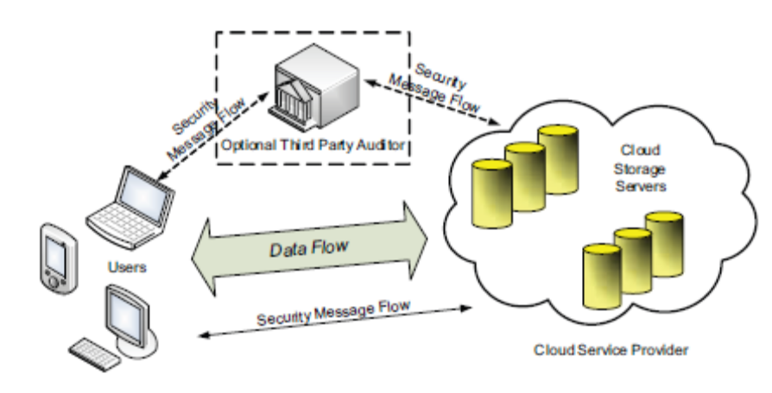

Data Flow Diagram:

ADD
REMOVE
ADD
VIEW
REMOVE
R. IP Add
Imp Files
User Name:
Password :
USER LOGIN
Very Imp. File
Dup. List
ADMIN
192.160.100.36
192.160.100.42
192.160.100.53
Pin.db
Password.db
Emp.db
Cloud Server Data Security Architecture Diagram
Pin.db
Administrator

Users

Log Text

Ip add:192.168.100.53
ADMIN
Time:10:30:45

DFD Client:
USER
EXISTING
USER
CONNECT WITH THE SERVER
NON-EXISTING
USER

REGISTER WITH THE SERVER
ENTER USERNAME & PWD
IS VALID
NO
YES

ACTIVITY DIAGRAM

An activity diagram is characterized by states that denote various operations. Transition from one state to the other is triggered by completion of the operation. The purpose of an activity is symbolized by round box, comprising the name of the operation. An operation symbol indicates the execution of that operation. This activity diagram depicts the internal state of an object.
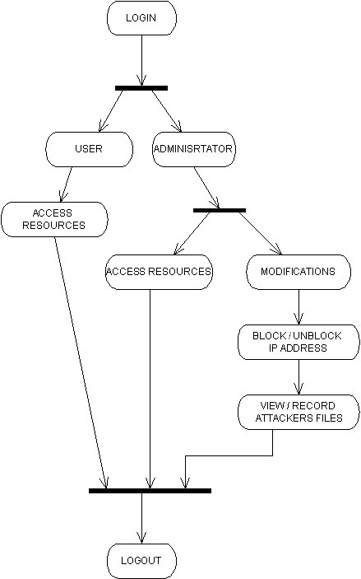

Fig. Activity Diagram

UML SEQUENCE DIAGRAM

The sequence diagrams are an easy and intuitive way of describing the
system’s behavior, which focuses on the interaction between the system and the environment. This notational diagram shows the interaction arranged in a time sequence. The sequence diagram has two dimensions: the vertical dimension represents the time, the horizontal dimension represents different objects. The vertical line also called the object’s lifeline represents the object’s existence during the interaction.
Client
Cloud Server
DataBase
invoke
connection established
connected
validation
user name,password
to verify
verified
valid/invalid user
valid user
file requested
checked
original/fake
file shown
exit
Fig. Sequence Diagram

CLASS DIAGRAM
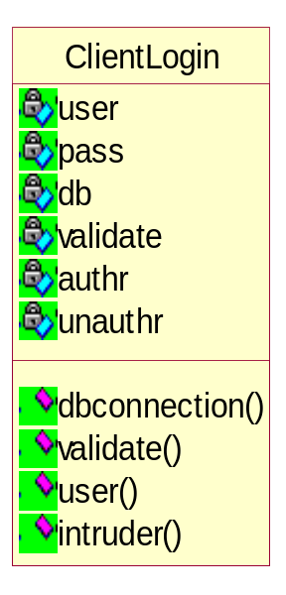
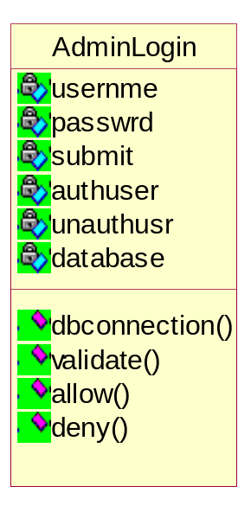

Fig Class Diagrams








CloudServer
database
validation
showres
invalid
showfake
pass
wrtefile
dbconnection()
validation()
showfiles()
download()
invalid()
showfake()
wrtefile()

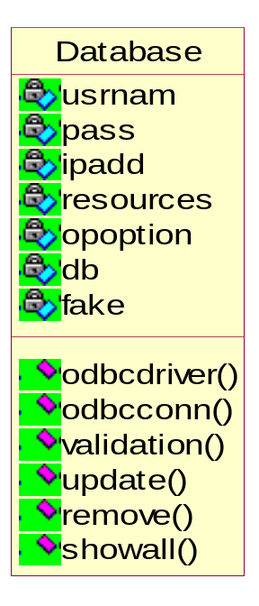
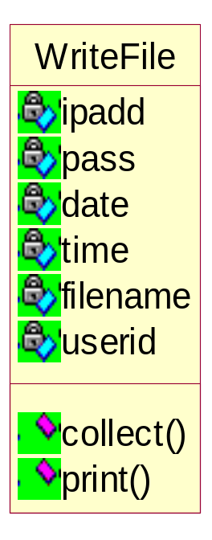

Fig 4.3 Class Diagrams
USE CASE DIAGRAM

A use-case diagram is a graph of actors, a set of use cases enclosed by a system boundary, participation associations between the actors and the use-cases, and generalization among the use cases.
In general, the use-case defines the outside (actors) and inside(use-case) of the system’s typical behavior. A use-case is shown as an ellipse containing the name of the use-case and is initiated by actors.
An Actor is anything that interacts with a use-case. This is symbolized by a stick figure with the name of the actor below the figure.
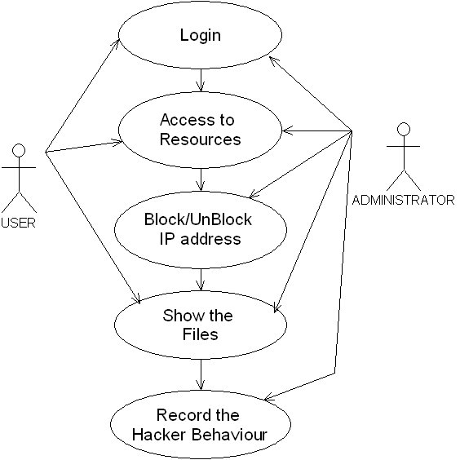
Fig Use case Diagram

